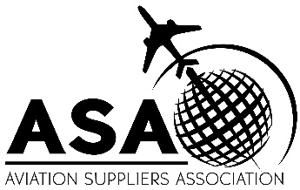
AVIATION SUPPLIERS ASSOCIATION
Quality Committee
December 2, 2022
Dallas, TX
MEETING AGENDA

8:00 am | Welcome; Antitrust Statement | George, J Dickstein
8:05 am | Participant Introductions | Committee
8:20 am | ASA Announcements | M Dickstein
8:40 am | ASA-100 Program Update | O’Connor
9:00 am | Transition requirements for AS9104 (2022 rev), and how this will affect the members and their certification bodies. | O’Connor
9:15 am | AS9100, AS9110, AS9120 Update | O’Connor
9:30 am | BREAK
10:00 am | Update: ASA 2020 Statement being adopted by industry software providers | M Dickstein
10:10 am | ASA-100 Proposed Changes | Knights
11:30 am | LUNCH
12:30 pm | CASE Update | Willyard
12:50 pm | Review of US-UK repair station relationship | J Dickstein
1:00 pm | A review of current guidance concerning documentation requirements for US-based EASA 145 holders | J Dickstein
1:10 pm | Current limits on Russian export and import transactions | J Dickstein
1:30 pm | Export analysis fact patterns | Knights
1:50 pm | Review of CCAR-145 updates based on CAAC public presentation | J Dickstein
2:10 pm | Discussion: What can ASA do to support members who are asked for repetitive / redundant QA surveys? | M Dickstein, Committee
2:30 pm | Discussion: What are members experiences with repair orders in the wake of the E-100 retirement? are there issues that need to be addressed? | George, Committee
2:50 pm | New Business and Open Discussion | Committee
3:00 pm | ADJOURN

Thank you to our sponsor,
We really appreciate your support!

